Chun Zheng

Description of the List box Help functions

MatCycle_LB
Because matlab has a hard time outputting a matrix in a list box properly. This is so that the data can be easily read and modified. If you read the code for this, this may seem like a long winded way of doing this. However if you experimented with this problem long enough you will see that this is the best solution to solve this problem.

This can be done with three functions getMatToUndStr(m), getUnd2BStr (in),
getMat2BlStr(mat)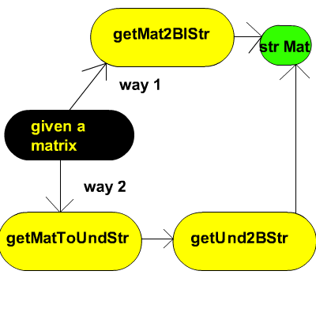

For practical purposes, you should always choose way 1, which is just a condensed form of way 2.

There’s also the setStrMatEntry function which is just a mutator for a regular matrix. The only real difference is that it returns a string matrix so that you can display it on a list box.

showEq(ftnStr,constStr)
This is for people who want to handle a system of equations in a neat compact fashion. Say that you have a bunch of constants that you want to modify, but also would like to do it in a quickly too. This function will help make that happen.
If you are importing a string from a load function, then you can ignore the part below where you create the cells with the brackets. Otherwise you need to create the variable as a cell first and then turn them into a string.

constStr=[{'x=1'} {'y=2'} {'z=3'}]'
ftnStr=[{'a=x*b'} {'c=y*z*d'}]';
%make each cell a string
constStr=char(constStr);
ftnStr=char(ftnStr);

once that’s done, you just call sysEq=showEq(ftnStr,constStr) and voila, it’ll return a string of a system of equations with the constant substitution! If you want to see a full example, check out my sysEq gui.

saveStrEqValToFile(dirFile,str)
This method is pretty straight forward; it basically saves a vector of constants onto a text file. The format must be str=[ firStrCons=num secStrCons=num2...]’;
Because this is straight forward, no example is shown in this file. If you want to see a full example, check out my sysEq gui.

Modify all the constant values or anything that has the form String(variable=number)
modVerTxtEq(ithEq,allEq,newFtnStr)
subfunction: modHorTxtEq(oldFtnStr,newFtnStr,caseNum)

-The purpose of these 2 functions is to regulate the spacing and keeping the same length for each column whenever the constant values are modified. In the code, I did every time the constant is changed, it will update the system of equations with the new constants.

The newer quicker way of doing this is called
modIthRowStr(ithRow,Str,ithRowStr) which takes the same exact parameters as modVerTxtEq

getNextIter(ftnStr,ICStr,ICVal)
This helps recursive effect based on your system of equations.

If you are planning to use any of these functions, please credit me for it in your work! :)

